# **SEMINAR REPORT**

# **ON**

# **SOLID WASTE MANAGEMENT**

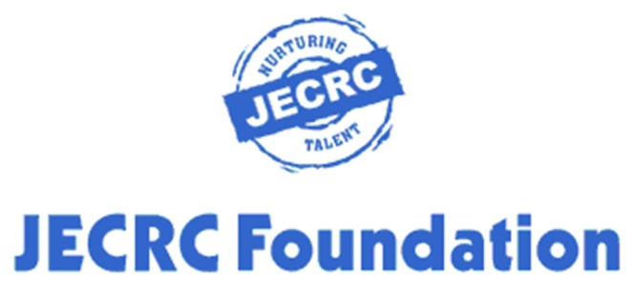

**Submitted To Submitted By Mr. Ashutosh Sharma RITIKESH (15EJCEC172)**

**DEPARTMENT OF ELECTRONICS & COMMUNICATION ENGINEERING JAIPUR EGINEERING COLLEGE AND RESEARCH CENTRE SITAPURA, JAIPUR (Raj.)-302022**